


openSIS Billing module Guide

Last updated: September 2011

openSIS billing module Guide

Table of Contents Page
1) Application navigation 3

2) Setup 3

3) Transction 4

4) Fee set up 4

5) Payment 5

6) Reports 6

7) Balance report 6

8) Daily transaction 6

Application Navigation

Fig 1(a) billing module navigation
List of main menu and Submenu items:
Reports
- Balance Reports.
- Daily Transaction.
Transaction
- Fee.
- Payment.
- Mass fee.
- Mass payment.
Setup
- Setup payment type.
- Set up fee type.
Setup:
To setup billing module first setup payment type.
Go to Billing >> Setup Payment Type
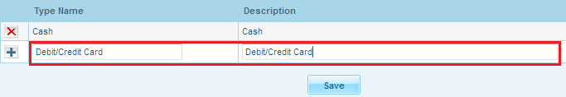
Fig 2(a) Payment type setup
Fill up necessary data and click on save. Your payment type is set now.
Next you need to setup fee type.
Go to Billing >> Setup Fee Type. Fill up the form and click on save
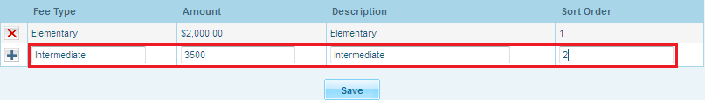 Fig 2(b) Setup Fee Type
You have set the module up for ultimate use.
Transaction
Fee set up
To start transaction, first set up the fee. You can set the fee individually or you can go for mass fee.
Mass Fee
Go to Billing >> Mass Fee
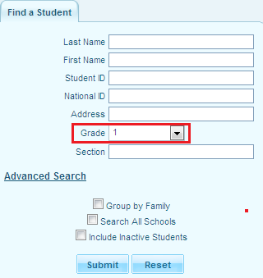
Fig 3(a) Find students for mass fee
Find students from the search box with proper criteria see fig 3(a).
Here you will get the list of students and a fee form see fig 3(b)
Fill up the form as shown in fig 3(b)
Select students from check box and save the setup.
The fee is now setup for selected students.
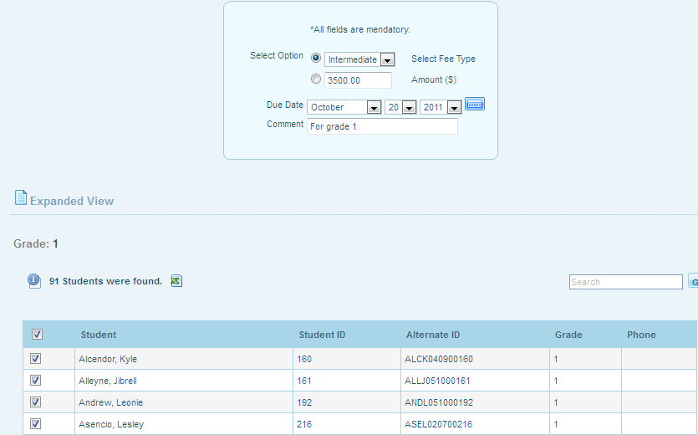
Fig 3(b.1) mass fee list
Individual fee
Go to Billing >> Fee
Find individual student from search box with proper criteria.
Fig 3 (b.2) individual fees set up form
Fill up the form as shown in fig 3 (b.2) now click on save. Fee is set for the individual student.
Waive
Go to Billing >> Fee
To waive fee for any student click on find the student
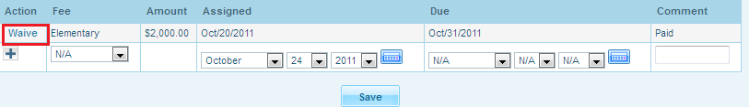
3(b..3) Waive
Click on student to get Payment details, then click on waive see fig 3(b.3) .
Payment
Here payment can also be operated individually or collectively.
Individual Payment
Go to Billing >> Payment
First find a student from the search box with proper criteria
Next you will get a payment form just fill it up with proper data as shown in Fig 3(c) and save.
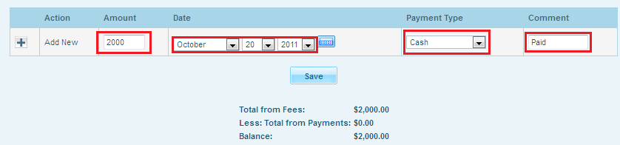
Fig 3(c) Payment
Mass Payment
Go to Billing >> Mass Payment
Find the students from search box
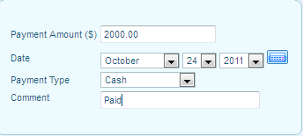
Fig 3(d) mass payment
Fill up the form and select the students from the list see fig 3(e)
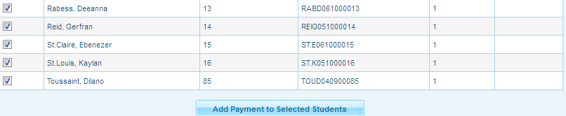 Fig 3(e) student list for mass payment.
Click on Add payment to selected student, mass payment is done.
Reports
Balance Reports
Go to Billing >> Balance Reports
To get the balance reports find students from the search box with proper criteria see fig 4(a).
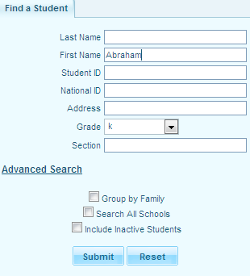
Fig 4(a) find student
You will find a list of students with balance report
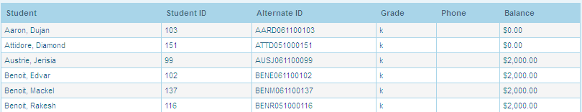
Fig 4(b) balance report
Daily Transaction
To get report on daily transactions
Go to Billing >> Daily Transaction.
The student search box will appear, perform the search with proper criteria, you will get a list.
Click on the list as shown in see fig 4(c)
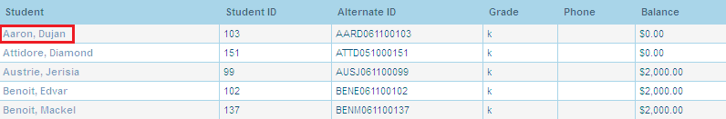
Fig 4(c) daily transaction list
transaction details for particular student will be shown as fig 4(d).
Fig 4(d) daily transaction details

